
Relationships and Behaviour Policy

Christ at the Centre
Autumn 2023

Mission Statement and Values

Christ at the Centre
Rejoice | Respect | Resilience

- Statement of Intent
Christ at the Centre

At the heart of everything we do at St Philip’s is the belief that all children are created and loved by God. It is because of this that they deserve the highest possible standards of teaching and learning through a positive and caring ethos in which relationships between all stakeholders can flourish.

Our Mission Statement encourages a journey of fulfilment with God and for this reason we must teach our children that positive behaviour for learning is an expression of loving God and loving each other. All children regardless of race, gender, gender status, sexual orientation, age, religion or disability have a right to feel safe at school. We teach our children about the protected characteristics to better support their understanding of respect to all people.
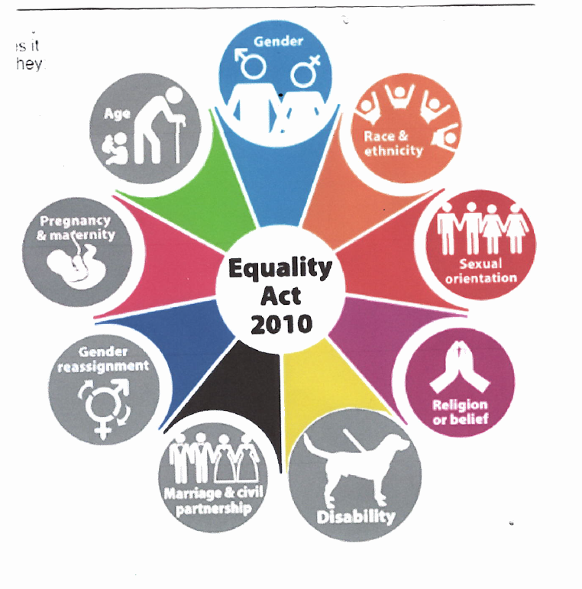

Our Relationships and Behaviour Policy is based on the belief that:
• Children have a right to learn and teachers have a right to teach in a classroom free from disruptive behaviour.
• Good behaviour is not automatically learned but needs to be taught and supported by parents.
• Classroom behaviour can change and that we as teachers can assist children to manage their behaviour more effectively.

- Values and Rules

Our school values permeate every aspect of our school life:
We REJOICE that each of us is a unique individual, created and loved by God.

We RESPECT everyone regardless of age, race, gender, sexual orientation, gender status, religion or background.

We develop RESILIENCE so that we can always do our best and be the very best that we can be.

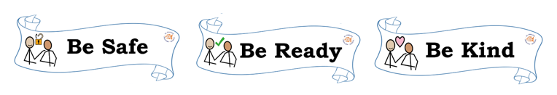
We have three school rules:

Expectations of Adults
We expect every adult to:

1. Meet and greet every child every morning
2. Make explicit reference to our School Values and Rules.
3. Model positive behaviours and build relationships
4. Plan lessons that engage, challenge and meet the needs of all learners based on Quality First Teaching
5. Use the school rewards to celebrate success
6. Be calm and consistent in the application of rewards and sanctions
7. Demonstrate ‘Deliberate Botheredness’ – a deliberate daily act that is built into the teaching routine which enables children to feel important and valued, and gives them a sense of belonging.
8. Alert senior leaders to learners with more complex needs Senior Leaders

Senior leaders are not expected to deal with behaviour referrals in isolation. They are to stand alongside colleagues to support, guide, model and show a unified consistency to the learners.

Senior leaders will:
1. Support and trust staff in their decisions.
2. Take time to welcome children and family members at the start of each school day
3. Be a visible presence around school
4. Celebrate staff and learners whose effort goes above and beyond expectations
5. Regularly share good practice
6. Offer support to colleagues with managing learners with more complex needs

Expectations of Parents
Parents will:
- Support their child’s learning of the school rules.
- Follow the School Values (in line with our Respect Policy) when working co – productively with staff to support their child.
- Inform the school of any changes in circumstances which may affect their behaviour.
- Discuss any concerns with their child’s class teacher promptly.

‘The foundation of every school must be excellent behaviour. We should be keeping the focus on a visible culture of impeccable conduct, and making the consistency palpable, audible and highly visible.’
Paul Dix

- Positive Strategies:
Bee Points
We wish to encourage pride in the children but realise that this needs to be modelled and nurtured before it is intrinsic. Our main school reward is our Bee points system. Bee points are given to a child not merely for doing what is expected of them or for following school rules as this should be the norm. Bee points are given to children who do something exceptional in line with our school core values or within their academic work. Bee points are never taken away but collated and celebrated.

100 Bronze award.
200 Silver award.
300 Gold award
Bee Point Assemblies take place at the end of each term and celebrate those individuals who have achieved the Bronze, Silver or Gold Awards.

Rejoice Assembly
These happen each Friday and are led by a member of the Senior Leadership Team. Each staff member will choose an individual who has demonstrated one of the School Values during that week. Awards for writing and handwriting are also given.

Headteacher and Deputy Headteacher Award
Children who are demonstrating the School Values may be sent to the Headteacher or Deputy Headteacher. An award certificate will be given in recognition of their actions and behaviours.

Restorative approaches
St Philip’s Catholic Primary School is proud to be a Restorative School, which means we teach our children to build and maintain relationships. When things go wrong, as they sometimes do, we have forgiveness at the heart of all that we do. Restorative practice is a term used to describe a way of maintaining healthy relationships, resolving difficulties and repairing harm when relationships breakdown. We use structured conversations to support this (please see Appendix 1).

What are the key benefits of Restorative Approaches in schools?

- A safer, more caring and respectful environment.
- A more effective teaching and learning environment.
- Better relationships amongst staff and pupils.
- Greater emphasis on responses to inappropriate behaviour that seek to reconnect, and not further disconnect, young people.
- Emotionally literate pupils, who can express their feelings and show empathy towards the feelings of others.
- Restorative Approaches and Practices provide the foundation to build, maintain and repair relationships positively with the whole school community.

Pupil Support
As part of the Restorative Approach process the children are taught about the Zones of Regulation where they look to understand their feelings through the use of colours. Children are taught about identifying which zone they are in and how they can help themselves move to a calmer colour.
We also use the 4E’s, Empathy, Expectation, Empowerment and Evidence when communicating with our children.
The school recognises its legal duty under the Equality Act 2010 to prevent pupils with a protected characteristic from being at a disadvantage. Consequently, our approach to challenging behaviour may be differentiated to cater to the needs of the pupil.
The school’s special educational needs co-ordinator will evaluate a pupil who exhibits challenging behaviour to determine whether they have any underlying needs that are not currently being met. This may be supported from advice from specialist teachers.
For some children, they may need visual reminders to help refocus on our school expectations throughout the day. Some children may have a Positive ’Bee Ready’ points card to help meet their individual needs.

- Strategies for dealing with wrong choices

At St Philip’s, we encourage positive behaviour which reflects our Mission Statement and School Values. Our behaviour management approach is based on building strong relationships between adults and children. The use of positive reinforcement strategies will always be our default approach.
However, if a child is not responding to these strategies, there needs to be clear, consistent consequences chosen by the adult dealing with a specific incident. For children with SEMH needs, examples of these will be detailed through their individualised provision and My Plan. We will use knowledge of each child to make adaptations which will be discussed with parents/carers on an individual basis.

C1. Verbal interaction / Verbal intervention (as detailed above) with child and class teacher- the language of reminders and warnings will be used.

C2. Opportunity to reflect in a quiet space followed by restorative talk, this may involve the completion of a reflection sheet (please see Appendix 3) and may take place during class time, at break or lunch.

C3. Class teacher notifies SLT as soon as possible and they will speak with the child at lunchtime. Class teacher will hand any C2 forms to an SLT member to complete the C3 side with the child and to decide a positive strategy to reduce the likelihood of further incidents of the same kind occurring. Reflection time may be given. Class teacher to record this on CPOMs and will speak to the parent / carer after school on the same day.

Behaviours include (but are not exhaustive):
C1, C2, C3 | Possible strategies which could be used to make reasonable adjustments
Persistent low level behaviour including:  - Shouting Out.  - Unkindness towards others.  - Leaving their desk without permission  - Leaving the carpet during input/story without permission  - Refusing to complete the work set  - Refusing to get changed for PE  - Choosing to do another activity than the one the class are doing (reading/drawing on whiteboard etc.)  - Rocking on their chair  - Calling out/talking to a friend  - Not listening to instructions  - Playing/fiddling with equipment | - Differentiated learning space/work station within the classroom  - Fiddle toy  - Wobble cushion  - Whiteboard to write  - Timers  - Task planner  - Learning broken down  - Scaffolds  - Additional resources  - Individualised timetable  - Now and next board  - Limited choice  - Brain breaks  - Positive experience  - Class job  - Task differentiation  - Adult support/Peer support  - Learning intervention  Small group/paired learning  - My Plan adaptations

Behaviour Card
If a child needs more encouragement to make positive choices or to follow the school rules, they will be given an individual, personalised points card (please see Appendix 2). Targets are made in agreement with the child, an emotionally available adult and the child’s parent / carer. When a child gains the target amount of points a text message will go to the parent / carer. Behaviour Cards are implemented in relation to the child’s needs and progress. This ensures children receive the individual level of behaviour support required. The Behaviour Cards are reviewed with the child weekly and discussed in a weekly review meeting between an adult at school, most likely the class teacher and the parent / carer. An example of a Behaviour card can be found in Appendix 2, however, these cards will be adapted to meet the needs of the individual child.

Behaviour requiring a change of strategy
If further action is required due to a continuation of the negative behaviour and work related activities then the Head and SENCO / SLT should be informed and an action plan will be discussed. This will include the parents / carers and will involve a close monitoring of work and a setting of targets for positive reinforcement. Severely disruptive behaviour or aggression / violent behaviour towards staff should be referred to the Head immediately and the following procedures will be implemented:
SC1. Parents / carers will be contacted for discussion with the Headteacher and class teacher. This may lead to a request for outside agency involvement including the creation of an EHA.
SC2. Internal Suspension: An internal suspension is a strategy used that requires a pupil to be removed from class and to work in isolation until their behaviour improves and any issues resolved.
SC3. Following these steps the parents / carers will be warned that further serious incidents would lead to a consideration of a fixed term suspension. A behaviour contract will be signed between the child, the parents / carers and the school. An example of a Behaviour contract can be found in Appendix 4, however, these contracts will be adapted to meet the needs and challenges of the individual child.
SC3. Fixed term suspension: A fixed term suspension will be given when the behaviour policy has been breached and evidence is clear that keeping the pupil in school will seriously harm the welfare of pupils or staff in the school. Only the Headteacher may suspend a pupil.

Member of class staff
Member of SLT – Mrs Church, Mrs Heaney or Miss Rowland
Headteacher – Mrs Holland

Behaviours include (but are not exhaustive):

SC1, SC2, SC3 | Possible strategies which could be used (educational and protective)
- Leaving the school building  - Leaving the premises  - Spitting (directly at another)  - Scratching  - Pinching  - Hair pulling  - Hitting  - Kicking  - Fighting  - Biting  - Punching  - Throwing furniture  - Leaving the classroom  - Physical or verbal bullying  - Derogatory comments relating to the protected characteristics | Social story  Comic strip conversation  Conversation and exploration  Rehearsing and practising  Teaching about empathy  Apology / repair  Assist in repairs  Potential payment for damage/replacement  Differentiated learning space  Change of environment

These behaviours will be a sign of a child needing support and a child may be in a heightened, anxious state – possibly due to factors outside of school – please be aware and empathetic of this and that their behaviour is communicating a need.
If a child is not managing to display safe and kind behaviours, we need to teach the behaviour we want to see.
It could be a ‘quick catch up’
It could be listen, link and learn
It could be a natural consequence (clearing up a mess, mending something)
You may need to teach something, practise something,
Consequences can be educational and protective. We use the word proportionate to work out the consequence for a child e.g. a child has seriously disrupted the learning in class then the protective consequence is proportionate the child needs to have time away from the class to reflect on the harm the child is having on all the children, themselves and the teacher in the class. If a child has hurt another child in the playground, then proportionate the child needs a protective consequence of time away from the playground with an educational consequence about the impact of their actions that can happen to a child if they are hurt.
- Suspensions
Suspensions may be given for the following reasons: any form of physical assault such as, but not limited to, hitting, biting, kicking, scratching, persistently breaking the school rules, damaging school property. This list is not exhaustive and the Headteacher reserves the right to suspend a child in line with LA and DfE guidance due to the significance of any single action.
- Damage to school property
If a child damages school property it may fall upon the family to cover the cost of the repairs. This can be as part of a payment plan across a number of years.

Team Teach

During difficult and dangerous behaviours, our children need to encounter adults who are calm and consistent who respond in a predictable, consistent, empathetic way. Children need to learn to forgive themselves and others and we are role models for this. When a child is displaying difficult or dangerous behaviours we remember this means they are ultimately not feeling safe or happy. We need to work out what the trigger is for this behaviour and try to de-escalate. Staff are expected to use Team Teach tools to identify triggers and plan measures to reduce the likelihood of escalation. A child who has spent time in ‘crisis’ may need recovery time / time to calm down before any educational consequence or Listen Link Learn conversation takes place, this may be the following day. A change of face, where one adult replaces another as the person leading de-escalation or distracting a child to de-escalate behaviours are two strategies used at St Philip’s.

To prevent escalation an adult must show consistent, calm approaches while using the following strategies:
Limited choice:
- [Name of child]…put the pencil in the pot or on the table
- [Name of child]…sit on the chair or on the floor
- [Name of child]…work at that table or that table

Disempowering the behaviour:
- You can listen from there
- Come and find me when you come back
- Come back into the room when you are ready
The de-escalation script
- [Name of child]… I can see you might be / are feeling annoyed/angry/upset.
- I am here to help.
- You talk, I will listen.
- Come with me and …

Emotional Recovery:
- Different children need varying lengths of “cool down” times
- Cool down can be offered in a variety of locations within the school and will be personalised depending on need

The positive behaviour management strategies that Team Teach develops and promotes emphasise team building, personal safety, communication, and verbal and non-verbal de-escalation techniques for dealing with challenging behaviour which reduce the need for physical intervention.
However, there may be times when children need more help to become regulated / calm down. As a last resort, staff are trained to use positive handling techniques to ensure the child’s safety, the safety of other pupils and staff, or that property is not seriously damaged. Team Teach approaches are ways that are safe, and which provide opportunities for repair and reflection for everyone involved. At St Philip’s Catholic Primary School, we have adopted the Team Teach approach to manage challenging behaviour. Most of our teaching and non-teaching staff have been trained in the use of this approach and staff in school complete ongoing refresher training and advise staff on managing behaviour.
As such, the Team Teach framework is entirely compatible with Positive Behavioural Support (PBS) approaches for people with additional needs. “Team Teach techniques seek to avoid injury to the service user, but it is possible that bruising or scratching may occur accidentally, and these are not to be seen necessarily as a failure of professional technique, but a regrettable and infrequent “side-effect” of ensuring that the service user remains safe”. Staff ensure it is ‘necessary, reasonable and proportionate’ and in the ‘best interest of the child’ through a dynamic risk assessment when using Team Teach positive handling techniques.
If you have any questions about how we manage behaviour at school, or about the Team Teach approach please contact school and speak to the Headteacher

Appendix 1:

Restorative Approach questions

What happened?

What were you thinking / feeling when it happened?

How are you now?

Who else has been affected?
What do you need to do to feel better?

What needs to happen to put things right?

What are you going to do differently next time?

Appendix 2:
Behaviour Card
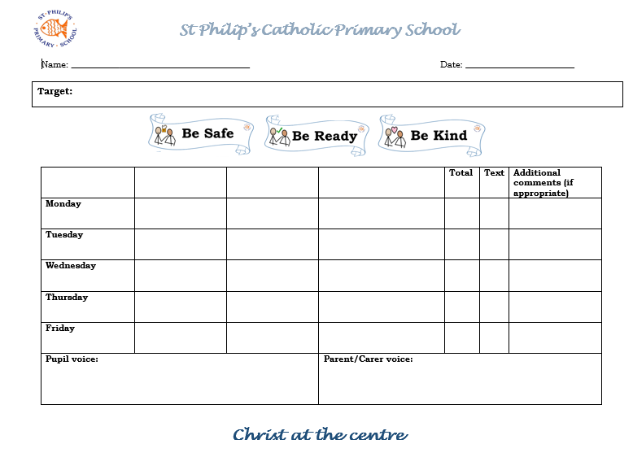

Appendix 3:
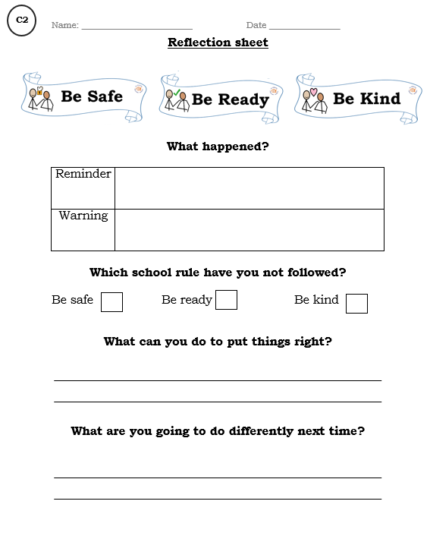
Reflection Sheet

Appendix 4:
Behaviour Contract
